Saint Ambrose Pre-School Handbook

2025-2026

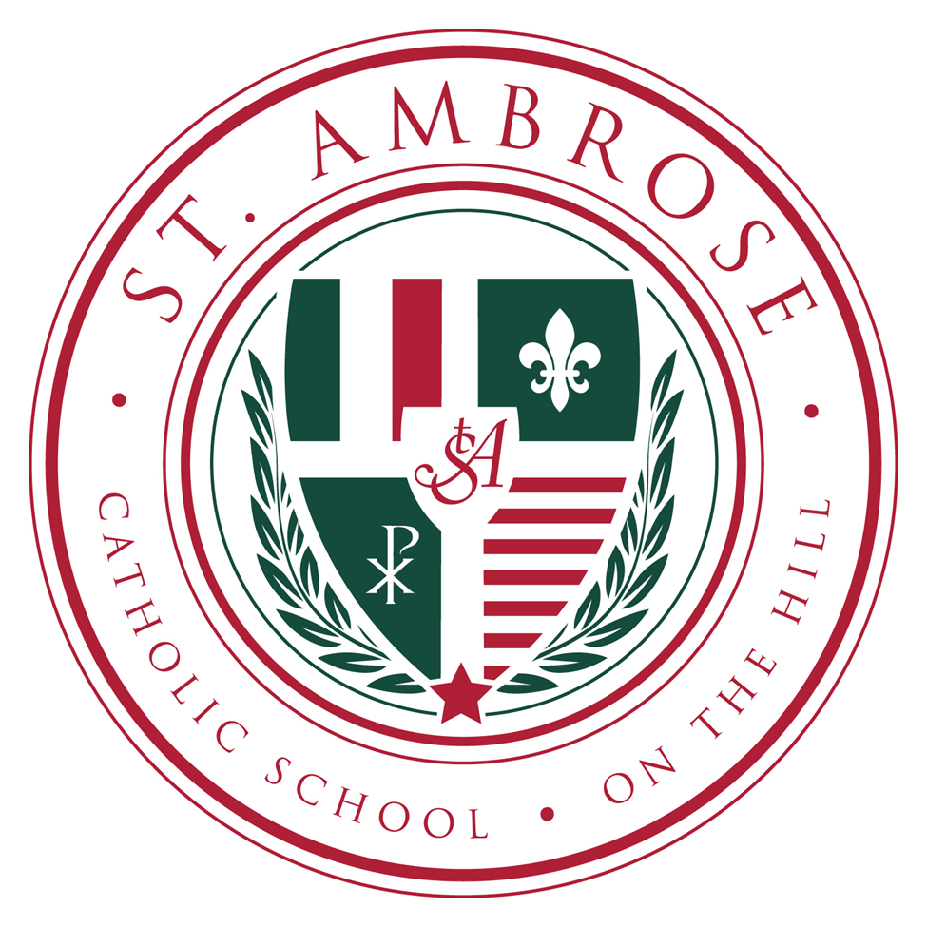

Father Jack Siefert, Pastor

Mrs. Michele Grellner, Principal

Revised June, 2025

Table of Contents

*Aims and Objectives* 2

*Admission* 3

*Potty/Toilet Training Policy* 3

*Quiet Time* 3

*Meals* 3

*Curriculum* 4

*Social/Emotional* 4

*Safe Environment* 4

*Uniform Policy* 4

*Shoe Policy* 5

*Supplies and Toys* 5

*Parent/Teacher Conferences* 5

*Arrival and Dismissal* 5

*Contacts* 6

# Aims and Objectives

Parents are the primary educators of their children. St. Ambrose strengthens and supports parents in this responsibility, by providing a learning environment that instills in the children a love for God, for learning, and for school. Our goal is for each child to experience love, trust, and individual success, thus strengthening his/her self-esteem. We also believe the best way to learn is by DOING. We provide experiences where children learn on all levels, and inspire a desire for lifelong learning.

* Students are given the opportunity to learn according to their own growth pattern and to develop self-confidence.
* The curriculum enables students to acquire and develop basic skills, understandings, attitudes and values, which help them to live as effective and happy persons in their environment.
* Students develop intellectually, spiritually, emotionally, physically, and socially.
* Children develop a positive for self-concept, love for life, knowledge and experience of God’s love.

# Admission

St. Ambrose accepts potty/toilet-trained children ages 3-5 years old. Children are admitted by the following age guideline, NO exceptions:

* 3 years old by August 1
* 4 years old by August 1

# Potty/Toilet Training Policy

Children enrolled in St. Ambrose **MUST** be fully potty/toilet trained before attending. Children must be wearing underwear with very few accidents. A child having accidents daily would not be considered potty/toilet trained. Children may not wear pull-ups or diapers.

We do understand that even potty/toilet trained children will occasionally have bathroom accidents. In these instances, the child must be able to change their clothes independently. Multiply accidents without a medical diagnosis and a note from the doctor may result in a parent meeting.

A potty/toilet trained child is one that can do the following:

* Communicate to the teachers that he/she needs to go to the bathroom.
* Alert him/herself to stop what he/she is doing and go to the bathroom.
* Pull down his/her clothes and get them back up without assistance.
* Wipe him/herself without assistance after using the toilet.
* Wash and dry hands.

# Quiet Time

Every child will rest/lay quietly each afternoon. If you need to pick up your child early from school, please let us know in advance so the class isn’t disturbed during this time period, and your student can wait in the office.

# Meals

Students have the option of purchasing hot lunch or bringing a lunch from home. We encourage you to pack a healthy balanced lunch. Hot lunch is provided by Chris’ Pancake and Dining. The menu is posted on FACTS.

No soda or carbonated drinks and glass containers are permitted at lunch. Students may bring a drink from home.

Parents should notify the office in writing of any specific food allergies or dietary needs. This can be explained in detail on the registration form.

Snacks: Students will need to bring a healthy snack each day.

Children’s Birthday Celebrations: As recommended by the Department of Community Healthy, commercially-prepared birthday treats may be sent to school by parents on the day of their child’s birthday. There must be enough treats for the entire class. When choosing treats, please be aware of students who have food allergies, particularly nut allergies. Little Debbie products may not be handed out due to allergens.

# Curriculum

St. Ambrose Catholic Elementary School follows the curriculum standards set by the Archdiocese of St. Louis.

# Social/Emotional

Throughout their time in preschool, the students will continue to develop social and emotional skills. This is the process through which children and adults acquire and effectively apply the knowledge, attitudes, and skills necessary to understand and manage emotions, set and achieve positive goals, feel and show empathy for others, establish and maintain positive relationships, and make responsible decisions.

# Safe Environment

The Archdiocese of St. Louis has developed a new system for safe environment compliance called Prevent and Protect STL. Everyone ministering to minors and vulnerable adults (clergy, employees, and volunteers) in the Archdiocese are required and asked to register in the new system. This includes those new to services and those who are currently in service. For those who have already attended a Protecting God’s Children workshop, your previous training date will transfer to this new system. In addition to attending a live Protecting God’s Children workshop, all clergy, volunteers, and employees will register for an updated background screening, view two new online training modules on abuse reporting and the Code of Ethical Conduct, and agree to the updated Code of Ethical Conduct. Please go to [www.preventandprtectstl.org](http://www.preventandprtectstl.org) to register.

# Uniform Policy

Hunter green polo shirts with the St. Ambrose logo (Just Me Apparel 232 Old Sulphur Spring Rd, 63021 or Maestro 1631 Sublette)

PreK may wear either the hunter green polo (Just Me Apparel) or the PreK t-shirt sold at Maestro.

Outerwear – Navy blue or hunter green fleece jackets, pullovers, sweaters and vest with the logo. (Just Me Apparel)

Khaki uniform slacks or shorts with plain pockets and no stitching (both boys and girls). No cargo pants or short shorts (belts are needed for grades 3-8).

Girls (PreK-4th) – Plaid jumper or skort (Just Me Apparel)

Tights – Navy blue, white, or black

Socks – Socks must be worn at all times and should be solid white or black. (If there is a log o on the socks, it must be either white or black with the exception of the St. Ambrose logo.)

This uniform will also be used for gym. Students may wear a T-shirt (plain solid shirt, no words or markers on the T-shirt) under the uniform shirt.

# Shoe Policy

Tennis shoes are required for safety reasons. Please no light-up shoes. Velcro shoes are preferred.

# Supplies and Toys

A supply list is emailed to families over the summer and posted on the website.

# Parent/Teacher Conferences

Parent/Teacher conferences are scheduled in the fall. You will receive an invitation prior to the conference. At the request of the teacher or parent, a conference may be scheduled at any time during the year when necessary.

# Arrival and Dismissal

The Pre-K 3 and 4 students should enter through the back door by the gym in the morning. The doors open at 7:30 AM, school begins at 7:45 AM. At 2:55 PM, the 4 year old classes will leave through the same door. The 3-year old classes will come out through the cafeteria door. Students will stay with their teacher until they are released to their guardian.

# Contacts

Church: School:

**Address:**

St. Ambrose Roman Catholic Church

5130 Wilson

St. Louis, MO 63110

**Phone numbers:**

314-771-1228 (Church Office)

314-771-0454 (fax)

**Email addresses**

Father Jack Siefert – [frjack@stambroseonthehill.com](mailto:frjack@stambroseonthehill.com)

Kim Boatman (bookkeeper)

[kim@stambroseonthehill.com](mailto:kim@stambroseonthehill.com)

Tina Hogan (marketing and development)

[tina@stambroseonthehill.com](mailto:tina@stambroseonthehill.com)

Lydia Thompson (Rectory Office Manager)

[lydia@stambroseonthehill.com](mailto:lydia@stambroseonthehill.com)

**Address:**

St. Ambrose Roman Catholic School

5110 Wilson Avenue

St. Louis, MO 63110

**Phone numbers:**

314-772-1437

**Email addresses:**

Michele Grellner (principal)

[mgrellner@stambroseonthehill.com](mailto:mgrellner@stambroseonthehill.com)

Lisa Horner (assistant principal)

[lhorner@stambroseonthehill.com](mailto:lhorner@stambroseonthehill.com)

Linda Gambaro (secretary)

[lgambaro@stambroseonthehill.com](mailto:lgambaro@stambroseonthehill.com)